H2 Computing Summarised Notes (Part 5)

Networking (in a Nutshell)

# Networking Fundamentals

## Part 1: Networks and Nodes

### 1.1 Network

A **network** is a group of devices that are **connected** together and can **communicate** and **share files and peripheral devices** (like printers) between each other.

### 1.2 Node

A **node** is a device or computer that is able to **connect to a network** and **generate, process and transfer data**.

Each node has **addressing information** (MAC address) in order to allow other devices to communicate with it.

#### 1.2.1 Endpoint

An **endpoint** is a node that acts as a **source** or **destination** for data transfer.

#### 1.2.2 Redistribution Point

A **redistribution** point is a node that **transfers data** between other nodes.

(examples: network switches, router)

## Part 2: Local Area Network (LAN)

### 2.1 What is a LAN?

A LAN is a computer network that covers a **small geographical area**.

(examples: home, office, school, a group of buildings)

### 2.2 Characteristics of LAN

A LAN is usually…

* Based in **one** or **more than one** building
* The organisation operating the LAN controls its **speed**
* The organisation operating the LAN is responsible for its **management** and **maintenance**
* There is a **choice of technology**.
* There is **no outside involvement** from telecommunications providers, unlike many WANs.

### 2.3 Network Configurations

A **network configuration** is a design specification for how the nodes of a network are **constructed** to **interact** and **communicate**, by determining the degree by which **communications and processing** are **centralised** and **distributed**.

#### 2.3.1 Centralised Network

A **centralised network** consists of a **central mainframe computer**, which **handles all** the communications and data processing in behalf of clients.

These ‘clients’ connect to the mainframe computer via **dedicated terminals/terminal emulators**.

##### Advantages

* These central mainframe computers are **high performance**.
* It allows for management in the LAN to be **centralised**.

##### Disadvantage

* It is generally **very expensive to implement**, not optimal for smaller businesses.

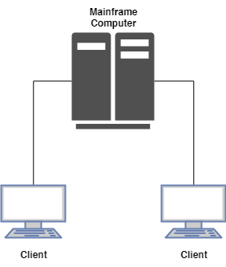

#### 2.3.2 Client/Server Network

A client/server network is one in which **servers provide resources** to **clients**.

Usually, there is at least one server that provides **central authentication services**. Servers also provide access to **shared files, printers, hardware storage** and **applications**.

In client/server networks, processing power, management services, and administrative functions can be concentrated, while clients can still perform many basic end-user tasks on their own.

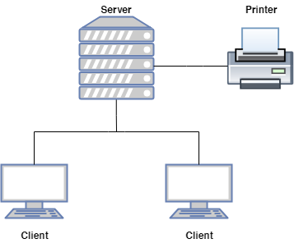

#### 2.3.3 Peer-to-Peer Networks

A **peer-to-peer network** is a network in which resource sharing, processing, and communications control are **completely decentralised**. There are (at least) **two communication parties** with **equivalent roles and responsibilities** in apeer-to-peer network.

**Services and resources are distributed** on each computer for other computers to access. All clients on the network are equal in terms of providing and using resources, and each individual device authenticates its users.

##### Advantages

* **Easy** and **inexpensive** to implement

##### Disadvantages

* + Data storage and authentication is **not centralised**, hence it is **only practical in very small organisations.**
  + User accounts must be duplicated on every device from which a user accesses resources. This distribution of user information makes **maintaining a peer-to-peer network difficult**, especially **as the network grows**.

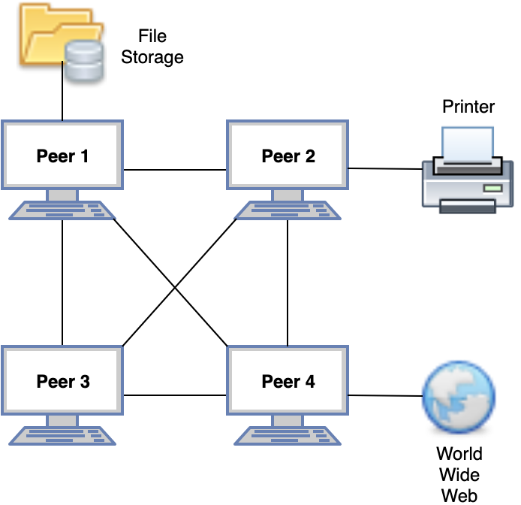

### 2.4 Network Topologies?

**These are not required in the A level syllabus.  
Network topologies** are the physical shape of the network. There are three types: **bus**, **star**, and **ring topologies**.

### 2.5 Types of Connections

#### Simplex Connections

A **simplex connection** is a connection that allows **communication in only one direction**, from the transmitter to the receiver.

#### Half-duplex Connections (HDX)

A **half-duplex connection** allows **communication to take place in both directions**, but only at **one direction at a time** (not simultaneously).

##### How half-duplex connections work

Typically, once a party begins receiving a signal, it must wait for the transmitter to stop transmitting before replying. Antennas are of trans-receiver type in these devices (transmitter and receiver) so as to transmit and receive the signal.

#### Full-duplex Connections (FDX)

A **full-duplex connection** allows **communication to take place in both directions simultaneously**.

##### How full-duplex connections work

These connections work by making simultaneous use of **two physical pairs of twisted cable**, where one pair is used for receiving packets (of data) and one pair is used for sending packets, to a directly connected device.

This effectively makes the cable a **collision-free** environment and **doubles the maximum data capacity** for a connection, as compared to a half-duplex connection.

#### Benefits of using full-duplex over half-duplex

##### Time is not wasted

**No frames need to be re-transmitted** using a full-duplex connection as compared to a half-duplex connection, as there are **no collisions**.

(In a half-duplex connection, if two or more stations/nodes transmit at the same time, signals will collide and become garbled.)

##### Full data capacity available in both directions

The **send and receive functions** in a full-duplex connection are **separated**, unlike a half-duplex connections where the same antennae send and receive data.

##### Nodes do not have to wait until others complete their transmission

This is because there is **only one transmitter** for each twisted pair in cables used in a full-duplex connection.

### 2.6 Interconnection of LANs

LANs need to be interconnected for various reasons:

* **Structure an organisation’s network**

Organisations are generally structured into divisions.  
Each one is likely to have its own LAN.  
To **enable communication** among the divisions, LANs need to be interconnected.

* **Extend maximum distance between stations/nodes**:

A division may be spread over several floors in a building.

Each floor is likely to have its own LAN.

Hence, there is a need to **interconnect these LANs.**

#### 2.6.1 Ways to interconnect LANs

**Ethernet LANs:** Ethernet Hub  
Ethernet Switch  
Bridge

**Different types of LANs:** Bridge

#### 2.6.2 Interconnection using Hub

It is a networking device used to **connect the nodes** in a network to **share files, data, and resources**.

A hub is a ‘non-intelligent’ device and does not manage any data flowing through it, hence it **broadcasts data** that it receives to all nodes in the network – even if the nodes do not request for it.

A hub can be connected in a **multi-tier design** with a backbone hub at its top, hence allowing interconnection of entire LANs.

##### Advantage:

* If one hub is down, the remaining network **continues to operate**.

##### Disadvantages:

* **Only one station/node can transmit at a time** in the entire network, otherwise, there would be collisions. (i.e. lack of traffic isolation in the network)
* **Not too many stations** can be connected in the network.

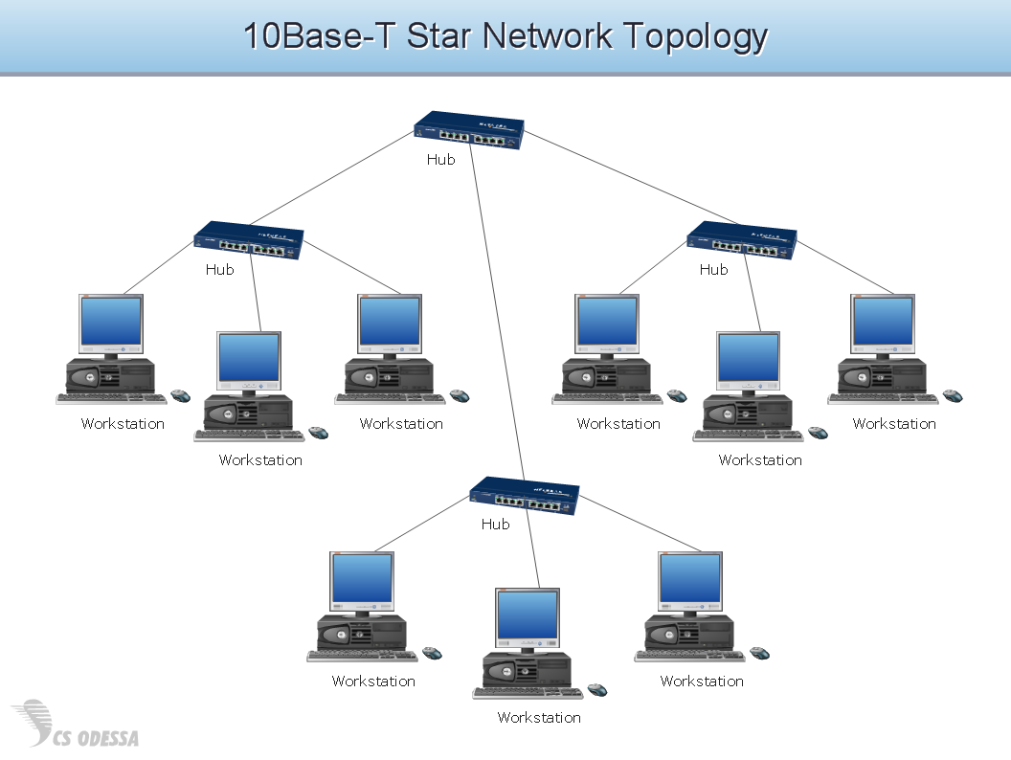

#### 2.6.3 Interconnection using Switch

A switch is a network device that acts as a **common connecting point** for various nodes or segments. It breaks the network into **LAN segments**.

However, switches are more ‘intelligent’ devices as it transmits data around the network more efficiently. This is because it **manages network data** by examining the Media Access Control (MAC) address of the destination node found in the data and **forwards messages** only to the receiving device.

Switches **filter frames**, **isolating traffic** in the network. The frames on the same LAN segment are not usually forwarded onto other segments.

Like hubs, switches can be connected in a **multi-tier design** with a backbone switch as its top. This leads to further performance improvement.

##### 2.6.4 Ethernet Switch

It contains two layers, the **physical** and **MAC layer**.  
It is capable of **buffering frames**.  
It examines **frame headers** and **selectively forwards** the **frame** based on the MAC destination address.  
Other links can be used to switch other frames simultaneously.  
Stations are unaware of the presence of the switch.

#### 2.6.5 Interconnection using Bridge

A bridge has the **same basic functionality** of a **switch**, but it **has fewer ports** and is **software-based**.  
It **passes messages** between two segments of a (bus) LAN.

It can be used to segment a bus networks into two segments.

Bridge also has two layers, just like the switch.

Bridges can **interconnect different LANs together** such that they **act as one single LAN** and allows two LANs to communicate with each other. This is done by converting the frame header according to the LAN on which a frame is being forwarded.

### 2.7 Network Architecture

#### 2.7.1 Client/Server Architecture

##### Roles

**Client/Server**: The client and server are **two communications parties** with **different roles and responsibilities**. Services and resources are placed on the server for the client to access.

**Server**: It **hosts resources** (e.g. files) or **offers services** (e.g. Internet banking).

It is **always on** to wait for connections to come in. However, servers may be turned off during periods of maintenance/fault.

It is usually given **permanent addresses** so that it can be accessed easily.

**Client**: It **communicates with servers** to access services and/or resources.

A client usually **does not communicate with other clients directly**. However, this is possible via a server.

##### What is a client/server architecture?

There is at least **one serving computer (the server)** which provides all the **client** machines with all the facilities they need, which is usually file and printer sharing.

##### Disadvantages

* **Cost**

With client/server computing, there is a need to purchase a **central serving machine** that should be **fast** and have **huge storage capacity**.

* **Reliance on one central system** for provision of services

If this central system (the server) fails, **access** to all information and to the services on this machine **would likely be lost**.

#### 2.7.2 Peer-to-Peer Architecture

In a **peer-to-peer architecture**:

* All nodes are **peer-to-peer**
* **No server** required
* A P2P node **may offer contents to others**. It makes this information available in the network.
* Other P2P nodes may access these contents **via direct communication**.

### 2.8 Intranet

An **intranet** is a **private network** that uses **Internet protocols and services** to share an organisation’s information with its members/staff.

Just like the Internet, these members/staff can access an intranet via a **regular web browser** and **navigate an organisation’s web pages**. An intranet usually contains information that is segregated from the Internet due to **privacy** and **confidentiality** reasons.

Therefore, an **intranet** provides all the features of the World Wide Web, but **access is usually given to a closed group only, normally controlled by a password**.

#### 2.8.1 Benefits of an Intranet

##### Over the Internet

* Access is **controlled**
* **More secure** than the Internet due to only authorised people having access
* **Faster** than the Internet as it usually covers a small area.
* **Less likely to crash** the websites due to less hits

##### Tangible Benefits

* **Inexpensive** to implement
* **Easy to use**, just point and click
* **Saves time and money**
* **Better information**, **faster** too
* Based on **open Internet standards**
* **Scalable** and **flexible**
* **Puts users in control** of their data

##### Intangible Benefits

* Improved **decision making**
* Improved **quality of life**
* Improved **productivity**
* Builds a **culture of sharing and collaboration**
* Facilitates **organisational learning**

### 2.9 Enterprise Networks

It is a network that **includes elements of both LANs and** **WANs**. It is owned and operated by a single organisation to **interlink its devices and resources** so that **users have access whether they are on or off premise** (i.e. allows for remote access).

They are designed for **fast data access**, **email exchange**, and **collaboration**. They are scalable and include **high-end equipment**, **strong security systems**, and **mission-critical applications**.

## Part 3: Wide Area Network (WAN)

### 3.1 What is a WAN?

Definition: a network that covers a **large area**, often across **multiple geographical locations** (e.g. all of an organisation’s offices in a country/among different countries).

## Part 4: Data Transmission

### 4.1 What is Data Transmission?

*Definition:* the **physical transfer of data** (a digital bit stream) **over a point-to-point or point-to-multipoint communication channel**.

### 4.2 Physical Media

**Guided media:** signals propagate in **solid media** (e.g. copper, fiber, coaxial)

**Unguided media:** signals propagate **freely** (e.g. radio)

### 4.3 Digital Signals

Digital signals can have combinations of only two values: **zero** and **one**. These signals can be translated into a **digital waveform**. A waveform can switch between two voltage levels: **0 for zero/ground voltage level** and **1 at a +ve/-ve voltage level**.

### 4.4 Digital Data Transmission

*Definition*: a form of data transmission that makes use of **voltage differences** to represent the ‘1’s and ‘0’s in data.

### 4.5 Unicast & Broadcast Transmission

#### Unicast Transmission

*Definition:* a method of data transfer from **a source address to a destination address**.

In unicast transmission, network nodes not involved in the data transfer ignore the transmission.

#### Broadcast Transmission

*Definition:* a method of data transfer from **a source node to all other nodes in a network**.

### 4.6 Rate & Speed of Data Transmission

#### Rate of Data Transmission

- Megabits per second (Mb/s – 1 million bits/s)  
 - Megabytes per second (MB/s – 1 million bytes/s)

#### Speed of Data Transmission

There are two types of measurements for data measurement speeds: **bit rate** and **baud rate**.

**Bit rate:**  Number of bits that are transmitted per unit of time

**Baud rate:** Number of symbols that are transmitted per unit of time

### 4.7 Transmission Modes

A given transmission on a communications channel between two machines can occur in several different ways. The transmission is characterised by:

* the direction of the exchanges
* the transmission mode: the number of bits sent simultaneously
* synchronisation between the transmitter and the receiver

#### 4.7.1 Simplex, half-duplex, full-duplex connections

##### Simplex Connection

*Definition:* A connection in which data flows in only **one direction**, **from the transmitter to the receiver**.

*Bandwidth:* **Full bandwidth**, as the transmission operates in one direction

*Examples:* Radio, television broadcasts

##### Half-duplex Connection

*Definition:* A connection in which data flows in **one direction** and the **other**, but **not both at the same time**.

*Bandwidth:* **Full bandwidth**, as the transmission operates in one direction at a time

##### Full-duplex Connection

*Definition:* A connection in which data flows in **both directions at the same time**.

*Bandwidth:* **Half bandwidth**, as the transmission can operate in both directions simultaneously.

#### 4.7.2 Serial and Parallel Transmission

The transmission mode refers to the number of elementary units of information (bits) that can be simultaneously translated by the communications channel.

##### Serial Transmission

*Definition:* A form of data transmission where **data are sent one bit at a time over the transmission channel**, as **one per clock cycle**.

*Used in:* Ethernet, keyboards, mice, etc.

However, as most processors process data in parallel, the transmitter has to transform parallel data to serial data and vice versa for the receiver.

##### Parallel Transmission

*Definition:* A form of data transmission where **multiple bits are simultaneously transmitted over multiple transmission channels/lines**.

These bits are sent simultaneously over multiple different lines, which either consists of:

* Multiple physical lines (such as several wires in a ribbon cable), or
* One physical line split up into multiple sub-channels by dividing up the bandwidth. Each bit is sent along the sub-channel at a different frequency.

*Limitation*: For parallel transmission, since conductive wires are close to each other in the ribbon cable (*N* physical lines), **interference may occur** especially at high speeds that may **degrade the signal quality**.

#### 4.7.3 Synchronous and Asynchronous Transmission

Given the problems that arise with a parallel-type connection, serial connections are normally used. However, since a single wire transports the information, the problem is how to synchronise the transmitter and the receiver – the receiver may not necessarily distinguish the characters because the bits are sent one after the other. To address this problem, there are 2 types of transmission that can be used:

##### Asynchronous Transmission

The sender **inserts special start and stop patterns** between each byte of data. By watching for these bit patterns, it **allows the receiver to distinguish between bits** in the data stream.

* **Each individual character is complete in itself** – corruption of a character during asynchronous data transmission does not affect the preceding and succeeding character.
* **Suited for applications where characters are generated at irregular intervals** (e.g. data entry from the keyboard)
* Successful transmission **depends on recognition of start bits** – they can be easily missed
* A **high proportion of the transmitted bits are used for control** (start, stop bits) and carry no useful information ( $\frac{ \text{3} }{\text{11}}$ for ASCII code)
* These distortion effects **limit transmission speeds**.

As a result, this is normally only used for **speeds up to 3000 bits/second**, with only simple, single character error detection.

##### Synchronous Transmission

A byteis sent after a **standardised time interval**. The receiver **assumes that one byte is transmitted every interval**. Two devices must **start and stop their reckoning** of these intervals at **exactly the same time**.

Synchronous devices include a clock chip. A special bit pattern is inserted at specific intervals in the data stream, enabling the receiving device to synchronise its clock with the sender.

* The amount of central information that has to be transmitted is restricted to **only a few characters at the start of each block**.
* The system is **not that prone to distortion** as asynchronous communication and can thus be **used at high speeds.**
* If an error occurs during transmission, the **whole block of data is lost** instead of just a single character (can consist of >100 characters).
* The sender **cannot transmit characters simply as they occur** and consequently **has to store them** until it has built up a block – **unsuitable for applications where characters are generated at irregular intervals**.

As a result, this is normally used for **high-speed communication** between computers.

### Asynchronous Transmission vs Synchronous Transmission

* Serial transmission can be either asynchronous or synchronous.
* In synchronous transmission a receiver and transmitter is synchronised and a block of characters is transmitted along with the synchronisation transmission while asynchronous transmission is character-oriented meaning each character carries start and stop bits
* Synchronous transmission is used for high speed transmission while asynchronous transmission is used for low speed transmission.

### 4.8 Circuit Switching and Packet Switching

#### 4.8.1 Router

*Definition:* A router is a networking device that **connects multiple networks**. It **forwards packets** from one network to another. It allows a LAN and a WAN to be connected.

*Components:* **Routing table:** maps output ports for different network addresses.

**Routing protocol:** exchange routing information, construct routing table.

**Buffer at o/p port:** stores packets before they are transmitted out.

#### 4.8.2 Circuit Switching

*Definition:* Circuit switching provides a **dedicated communications channel** for **two nodes to communicate** with each other. This communications channel is set up **before the nodes communicate**. The circuit guarantees the **full bandwidth** of the channel until the communication session ends.

#### 4.8.3 Packet Switching

##### Process:

**At the sender**

1. The data to be sent is **split up into multiple packets** of a certain size.
2. A header containing the **destination MAC address**, the **length of the data**, and the **packet sequence number** (determines the order to reassemble the packet at the receiver) is added to each packet.
3. The packets get **routed independently to its destination**, following different paths along its way.

**At the router**

1. The packet is **received** and **temporarily stored** (buffered) in the router
2. The packet is then **passed on** to the next router. The next router the packet goes to depends on the destination MAC address.
3. Steps 4 and 5 are repeated until the packet reaches the destination node.

**At the destination**

1. Once all the packets arrive at the destination, the packets are reassembled into the original data in the correct order using the **packet sequence number**.

### 4.9 Protocols

*Definition:* A computer network protocol establishes the **rules and formats** that must be **followed** for **effective communication** **between networks**, as well as from **one network node to another**.

#### 4.9.1 How do protocols work?

A protocol is a set of rules that governs communication between networks and between network nodes. This is done by **defining a set of valid messages**, such as its **structure or syntax**, as well as the **meaning of each message** (semantics).

#### 4.9.3 Examples of protocols

The main internet protocols are:

##### Hyper Text Transfer Protocol (HTTP)

Helps us display webpages. If a computer does not know HTTP, it would not be able to display a webpage.

##### File Transfer Protocol (FTP)

Helps us send and receive files from other computers.

##### Simple Mail Transfer Protocol (SMTP) / Post Office Protocol (POP3)

SMTP allows us to send emails; POP3 usually allows us to receive them.

### 4.10 Error Detection

When data is transmitted, it is possible for errors to be created during the data transmission process. Thus, error detection is the process of determining if **transmitted data has been received correctly and completely.**

Error detection is a cooperative activity between the sender and the receiver, in which the sender adds information to the character or frame to assist the receiver in determining whether an error has occurred in transmission or reception. Before sending, the sender and receiver must agree on the information that will be added, and how it will be used.

#### 4.10.1 Parity Checking

In computing, parity refers to the **evenness or oddness** of the **number of bits** with value one within a given set of bits, and is thus determined by the value of all the bits.

Parity checking is a form of error detection that checks for the parity of a data item sent over a data transmission.

##### Even Parity vs Odd Parity

**Even parity:** total number of bits in a byte (including parity bit) with value 1 must be even.

**Odd parity:** total number of bits in a byte (including parity bit) with value 1 must be odd.

##### Process:

**At the sender**

The sender adds a parity bit to the end of a string of binary code that indicates whether the enumber of bits in the string with the value one is even or odd.

#### 4.10.2 Checksum

A checksum is a form of error detection where all the bytes of a block of data is added and the overflow is removed (10 0010 1101 → 0010 1101), leaving only the lowest 8 bits/byte of the checksum.

##### Cyclic Redundancy Checksum (CRC) Process:

**At the sender**

The sender adds a parity bit to the end of a string of binary code that indicates whether the enumber of bits in the string with the value one is even or odd.

### 4.11 Error Correction

## Part 5: Cloud Computing

### 5.1 What is cloud computing?

Cloud computing is a form of Internet-based computing that refers to anything that involves **delivering hosted services over the Internet**.